Project Planning Phase
Project Planning Template (Product Backlog, Sprint Planning, Stories, Story points)

Date | 18 June 2026
Team ID
Project Name | SHOPEZ E-COMMERCE
Maximum Marks | 5 Marks

Product Backlog, Sprint Schedule, and Estimation (4 Marks)

Sprint | Functional Requirement (Epic) | User Story Number | User Story / Task | Story Points | Priority | Team Members
Sprint-1 | Authentication | USN-1 | As a user, I can register an account (Customer/Admin) | 4 | High | Team
Sprint-1 | Authentication | USN-2 | As a user, I can log in securely using my credentials. | 4 | High | Team
Sprint-1 | Authorization | USN-3 | As a user, I can access features based on role (Admin/User). | 5 | High | Team
Sprint-2 | Property Management | USN-4 | As an admin, I can add products with name, price, image, and category. | 7 | High | Team
Sprint-2 | Property Management | USN-5 | As an admin, I can edit and delete products from inventory. | 6 | High | Team
Sprint-3 | Property Search | USN-6 | As a user, I can view all available products on the homepage. | 4 | High | Team
Sprint-3 | Property Search | USN-7 | As a user, I can search products using search bar. | 4 | High | Team
Sprint-4 | Visit Booking | USN-8 | As a user, I can filter products by category. | 8 | High | Team
Sprint-4 | Booking Management | USN-9 | As a user, I can add products to cart. | 6 | High | Team
Sprint-4 | Negotiation | USN-10 | As a user, I can update quantity and remove items from cart. | 7 | Medium | Team
Sprint-5 | Administration | USN-11 | As a user, I can place an order using checkout page. | 8 | High | Team
Sprint-5 | Project Enhancement | USN-12 | As an admin, I can view and manage all customer orders. | 5 | Medium | Team
Sprint-5 | Branding & Documentation | USN-13 | As a developer, I can improve UI (navbar, layout, responsiveness).. | 5 | Medium | Team
Total Story Points = 73

Project Tracker, Velocity & Burndown Chart: (4 Marks)
Sprint | Total Story Points | Duration | Sprint Start Date | Sprint End Date (Planned) | Story Points Completed (as on Planned End Date) | Sprint Release Date (Actual)
Sprint-1 | 17 | 3 Days | Day 1 | Day 3 | 17 | Day 3
Sprint-2 | 13 | 2 Days | Day 4 | Day 5 | 13 | Day 5
Sprint-3 | 8 | 1 Day | Day 5 | Day 5 | 8 | Day 5
Sprint-4 | 21 | 3 Days | Day 6 | Day 8 | 21 | Day 8
Sprint-5 | 14 | 1 Day | Day 9 | Day 9 | 14 | Day 9
Total | 73 | 9 Days | - | - | 73 | -
Velocity:
Imagine we have a 10-day sprint duration, and the velocity of the team is 20 (points per sprint). Let’s calculate the team’s average velocity (AV) per iteration unit (story points per day)

AV=73/9=8.11

Burndown Chart:
A burn down chart is a graphical representation of work left to do versus time. It is often used in agile software development methodologies such as Scrum. However, burn down charts can be applied to any project containing measurable progress over time.
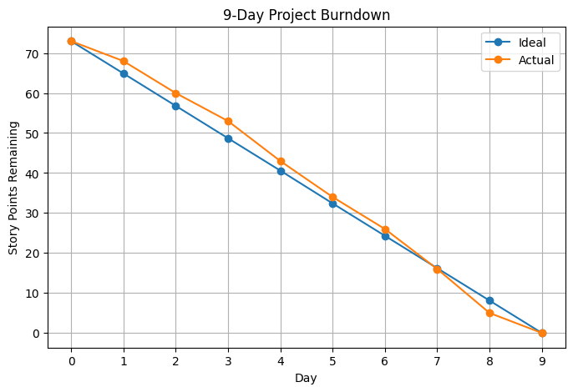

https://www.visual-paradigm.com/scrum/scrum-burndown-chart/
https://www.atlassian.com/agile/tutorials/burndown-charts

Reference:
https://www.atlassian.com/agile/project-management
https://www.atlassian.com/agile/tutorials/how-to-do-scrum-with-jira-software
https://www.atlassian.com/agile/tutorials/epics
https://www.atlassian.com/agile/tutorials/sprints
https://www.atlassian.com/agile/project-management/estimation
https://www.atlassian.com/agile/tutorials/burndown-charts

